MEGHNAD SAHA INSTITUTE OF TECHNOLOGY

*Techno Complex, Madurdaha,Beside NRI Complex, Post-Uchhepota, Kolkata 700 150*

LABORATORY NOTE BOOK

MAKAUT EVEN SEMESTER 2025



[MASTERS OF COMPUTER APPLICATION]

[OBJECT ORIENTED PROGRAMMING LAB USING JAVA (MCAN-293)]

[RUPAK SARKAR]

ROLL NO: 14271024036 REGN. NO.: 241420510045

STREAM: MCA SEMESTER: II (2ND)

YEAR: 1ST YearSESSION: 2024-2026



MAULANA ABUL KALAM AZAD UNIVERSITY OF TECHNOLOGY



MEGHNAD SAHA INSTITUTE OF TECHNOLOGY

*Techno Complex,. Madurdaha,Beside NRI Complex, Post-Uchhepota, Kolkata 700 150*

“LIST OF ASSIGNMENT/EXPERIMENT SUBMISSION DETAILS”

|  |  |  |  |  |  |
| --- | --- | --- | --- | --- | --- |
| **SL.**  **NO.** | **ASSIGNMENT / EXPERIMENT NAME** | **DATE OF EXPERIMENT** | **DATE OF SUBMISION** | **CHECKED BY** | **REMARKS (ANY DEVIATION REGARDING SUBMISSION DATES, CONTENT, FORMAT, ETC)** |
| 1. | WAP to find Sum and Avg of Integer Array. | 24/02/2025 | 03/03/2025 |  |  |
| 2. | WAP to find Sum of two 2D Arrays. | 24/02/2025 | 03/03/2025 |  |  |
| 3. | WAP to display elements of two uneven 2D Arrays. | 24/02/2025 | 03/03/2025 |  |  |
| 4. | WAP to search elements in an Array. | 24/02/2025 | 03/03/2025 |  |  |
| 5. | WAP to find sum diagonal elements in 2D Array. | 24/02/2025 | 03/03/2025 |  |  |
| 6. | WAP to find sum of odd numbers in 2D Array. | 24/02/2025 | 03/03/2025 |  |  |
|  |  |  |  |  |  |
|  |  |  |  |  |  |
|  |  |  |  |  |  |
|  |  |  |  |  |  |

|  |
| --- |
| OBSERVATIONS / COMMENTS ON THE OVERALL PERFORMANCE: |

Signature in full with date Signature in full with date

**Faculty / Technical Assistant Lab Examiner**

**Q.1. Write a java program to calculate Sum and Average of an integer array.**

Ans:

class sumndaverage

{

    public static void main(String args[])

    {

        int[] nums = {5,15,25,35,45};

        int sum=0;

        for (int numbers: nums)

        {

            sum+=numbers;

        }

        double average = (double) sum / nums.length;

        System.out.println("Sum : " +sum);

        System.out.println("Average : " +average);

    }

}

Output:

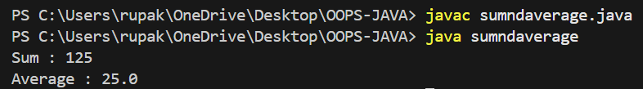

**Q.2. Write a java program to calculate Sum of two 2D arrays.**

Ans:

class sum2d

{

    public static void main(String args[])

    {

        int a[][] = new int[3][3];

        int b[][] = new int[3][3];

        int c[][] = new int[3][3];

        int i, j, k1 = 1, k2 = 1;

        for (i = 0; i < 3; i++) {

            for (j = 0; j < 3; j++) {

                a[i][j] = k1++;

                b[i][j] = k2++;

            }

        }

        for (i = 0; i < 3; i++) {

            for (j = 0; j < 3; j++) {

                c[i][j] = a[i][j] + b[i][j];

            }

        }

        System.out.println("Sum of matrices:");

        for (i = 0; i < 3; i++) {

            for (j = 0; j < 3; j++) {

                System.out.print(c[i][j] + "\t");

            }

            System.out.println();

        }

    }

}

Output:

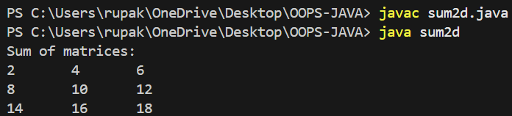

**Q.3. Write a java program to create 2D uneven array and display their elements.**

Ans:

class TwoD

{

    public static void main(String args[])

    {

        int TwoD[][]=new int[5][5];

        int i, j, k=1;

        for(i=0;i<5;i++)

        {

            for(j=0;j<i;j++)

            {

                TwoD[i][j]=k++;

                System.out.print(TwoD[i][j]+ " ");

            }

            System.out.println(" ");

        }

    }

}

Output:

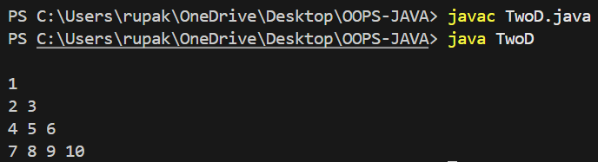

**Q.4. Write a java program to search elements in an array.**

Ans:

class SearchElem {

    public static void main(String args[]) {

        int[] arr = {10, 20, 30, 40, 50};

        int key = 30;

        for (int i = 0; i < arr.length; i++) {

            if (arr[i] == key) {

                System.out.println("Found at index: " + i);

                return;

            }

        }

        System.out.println("Not found.");

    }

}

Output:

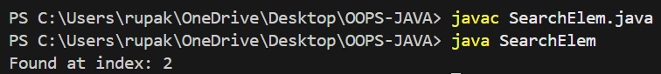

**Q.5. Write a java program to find the sum of diagonal elements in a 2D array.**

Ans:

class DiagSum {

    public static void main(String args[]) {

        int n = 3;

        int[][] arr = new int[n][n];

        int value = 1;

        for (int i = 0; i < n; i++) {

            for (int j = 0; j < n; j++) {

                arr[i][j] = value++;

            }

        }

        int sum = 0;

        for (int i = 0; i < n; i++) {

            sum += arr[i][i];

        }

        System.out.println("2D Array:");

        for (int i = 0; i < n; i++) {

            for (int j = 0; j < n; j++) {

                System.out.print(arr[i][j] + "\t");

            }

            System.out.println();

        }

        System.out.println("Sum of diagonal elements: " + sum);

    }}

Output:

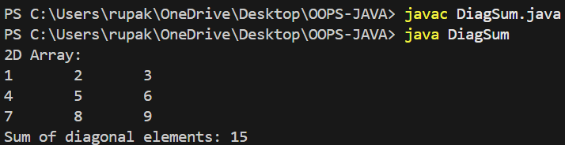

**Q.6. Write a java program to find sum of all odd numbers in a 2D array.**

Ans:

class OddSum2D {

    public static void main(String args[]) {

        int[][] arr = new int[3][3];

        int oddSum = 0, value = 1;

        for (int i = 0; i < 3; i++)

            for (int j = 0; j < 3; j++, value++) {

                arr[i][j] = value;

                if (value % 2 != 0) oddSum += value;

            }

        System.out.println("Sum of all odd numbers: " + oddSum);

    }

}

Output:

